【例4-60】创建预定义过滤器
I = imread('saturn.tif');
h = fspecial('unsharp',0.5);
I2 = filter2(h,I)/255;
imshow(I)
figure, imshow(I2)
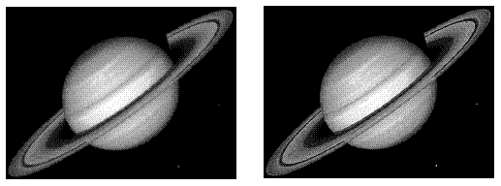
预定义过滤器

